**Kubernetes Task -2**

Installed and configured AWS CLI, eksctl, kubectl



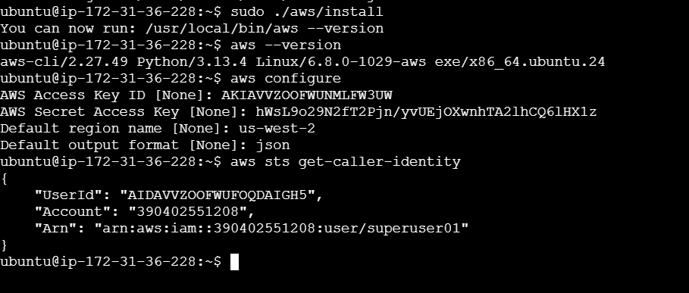

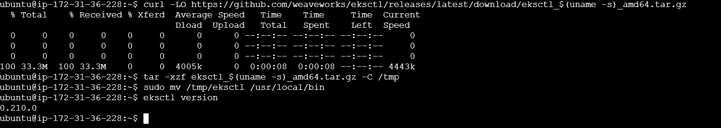

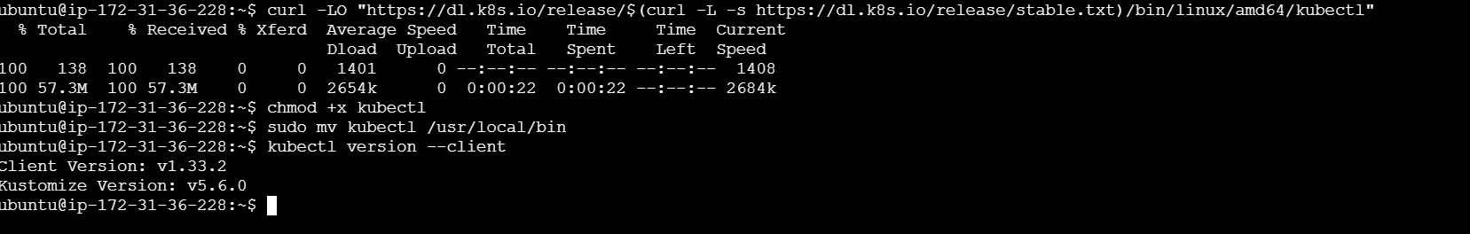

Created an EKS Cluster

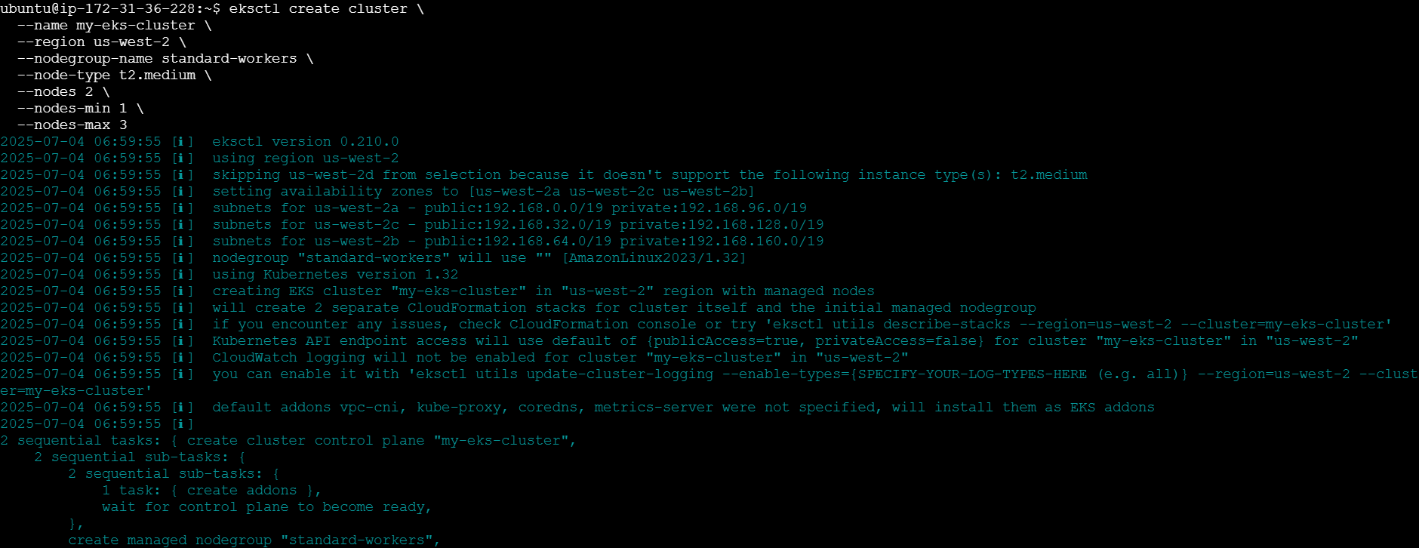

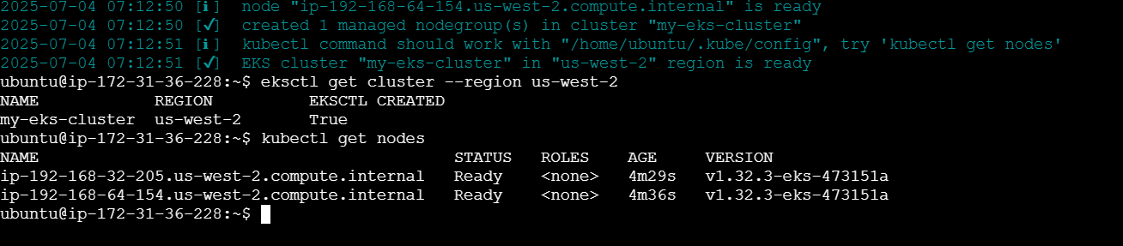

Deployed Nginx App

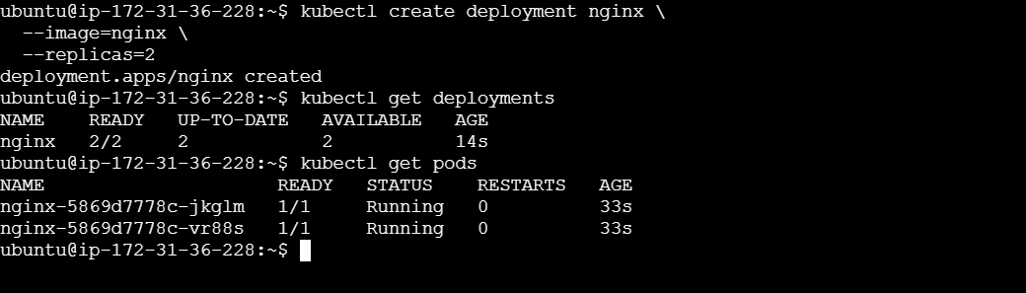

Exposed Nginx Publicly

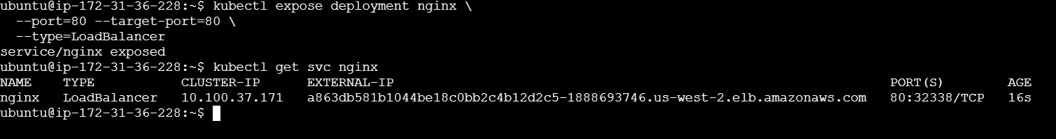

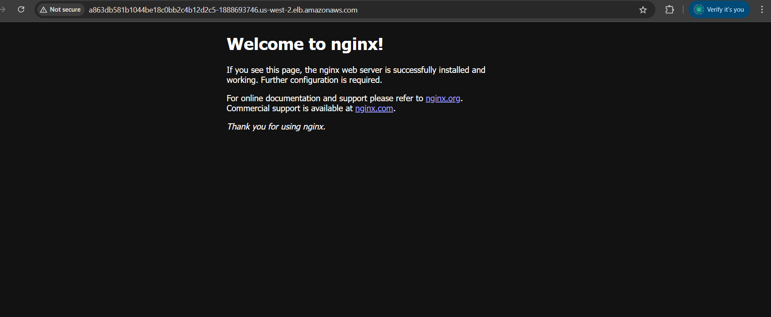

Cleaned up Cluster

